Information and advice for Orthodontic patients
Orthodontic emergencies occur occasionally and, although they may be a little upsetting for the patient and parents, they are usually simple to resolve by the patient or parents. But for some emergencies, patients may need to contact the practice for advice and attention by Dr Ian Arad.
The British Orthodontic Society has published videos to showing how to deal with commonly occurring Orthodontic emergencies at home.
Common orthodontic emergencies include:
- Food Caught Between Teeth
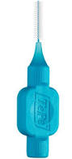
This can be a little uncomfortable or embarrassing for the patient. It is easily fixed with a piece of dental floss or use an interproximal brush or toothpick to dislodge food caught between teeth and braces.

- Lost Wire or Elastics Ligature
Tiny rubber bands or small fine wires, known as ligatures, hold the wire to the bracket. If a rubber or wire ligature is lost or totally disengaged, notify your orthodontist before your next appointment with your Orthodontist. It is not an emergency and your Orthodontist will put a new one next time you are seen.
- Ligatures Come Off
If a rubber ligature should come off partially, you or your guardian may be able to put it back in place using clean tweezers. If a wire ligature comes loose, simply remove it with clean tweezers. If the wire ligature is sticking out into the lip but is not loose, it may be bent back down with a cotton bud or pencil eraser to eliminate the irritation.
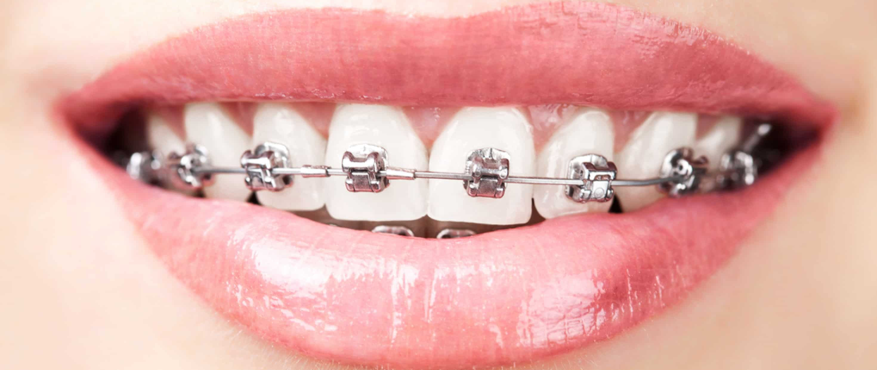
Of course, when one ligature pops off or breaks, others may follow. Missing or broken ligatures should be brought to the attention of your orthodontist at the next appointment.

- Irritation of Lips or Cheeks
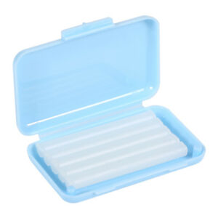
Sometimes new braces can be irritating to the mouth, especially when you are eating. A small amount of non-medicinal relief wax (Orthodontic Relief Wax) makes an excellent buffer between the brackets and mouth. Simply pinch off a small piece and roll it into a ball the size of a small pea. Flatten the ball and place it completely over the area of the braces causing irritation. You may then function more comfortably. If the wax is accidentally ingested it is not a problem. The wax is harmless.

- Protruding Wire
Occasionally the end of a wire may work itself out of place and irritate your mouth. You or your guardian may be able to put it back in place using clean tweezers. If the wire cannot be put back or moved into a comfortable position, cover it with Orthodontic Relief Wax.
In a situation where the wire is extremely bothersome and it is not relievable with the above measures, please contact the practice.
- Loose Brackets
If the braces have come loose in any way, you may be able to remove the ligature with a tweezer and bracket should slip out. If the bracket is not bothering you, it can just stay on the wire. You may need some wax to make it comfortable if it is twisting on the wire.
Should you notice a loose bracket please contact the practice for advice first.

- Piece of the appliance is swallowed or aspirated.
If a piece of the appliance is swallowed, there should be no coughing or difficulty in breathing. Usually the conservative approach is taken, and the piece is allowed to pass naturally, but please call the practice as soon as possible. Very rarely, a piece of the appliance can be aspirated (caught in the airway). If you are coughing excessively or having difficulty breathing, the piece could have been aspirated. When this happens, you must remain calm. If you can see the piece, you may carefully attempt to remove it. But do not make the attempt if you would cause harm.
If you are unable to see the piece and believe it may have been aspirated, you should attend an A&E Practice immediately.

- Aligners (including Invisalign)
If any of the attachments have come loose, please don’t worry. Wear your aligners as you have been advised until you are seen again. Due to the current situation you may be advised to wear your aligners for 2 weeks each instead of the one-week protocol. This is may be needed if you require slenderising or interproximal reduction of your teeth before you can move to the next aligner or you cannot get to us to have the next sets of aligners. Please wear the last aligner just at night as a retainer till we can see you again after they have been worn for two weeks fulltime. Should your current aligner break please move back to your previous aligner. Should neither option be possible or if you are experiencing any other issues please contact the practice for advice as soon as possible.

- Lost retainers or broken bonded retainers
We may not be able to make you a new retainer as most labs are closed and the rest may close in a week or two. Please make sure you keep hold of your current retainers and not lose them. If your bonded or fixed retainers has come off or broken on one tooth, try and wear your removable retainer every night for 12 hrs until you can be seen when the practice reopens for routine care. You can also try and push the loose wire back towards the tooth as much as possible. You can also use.

