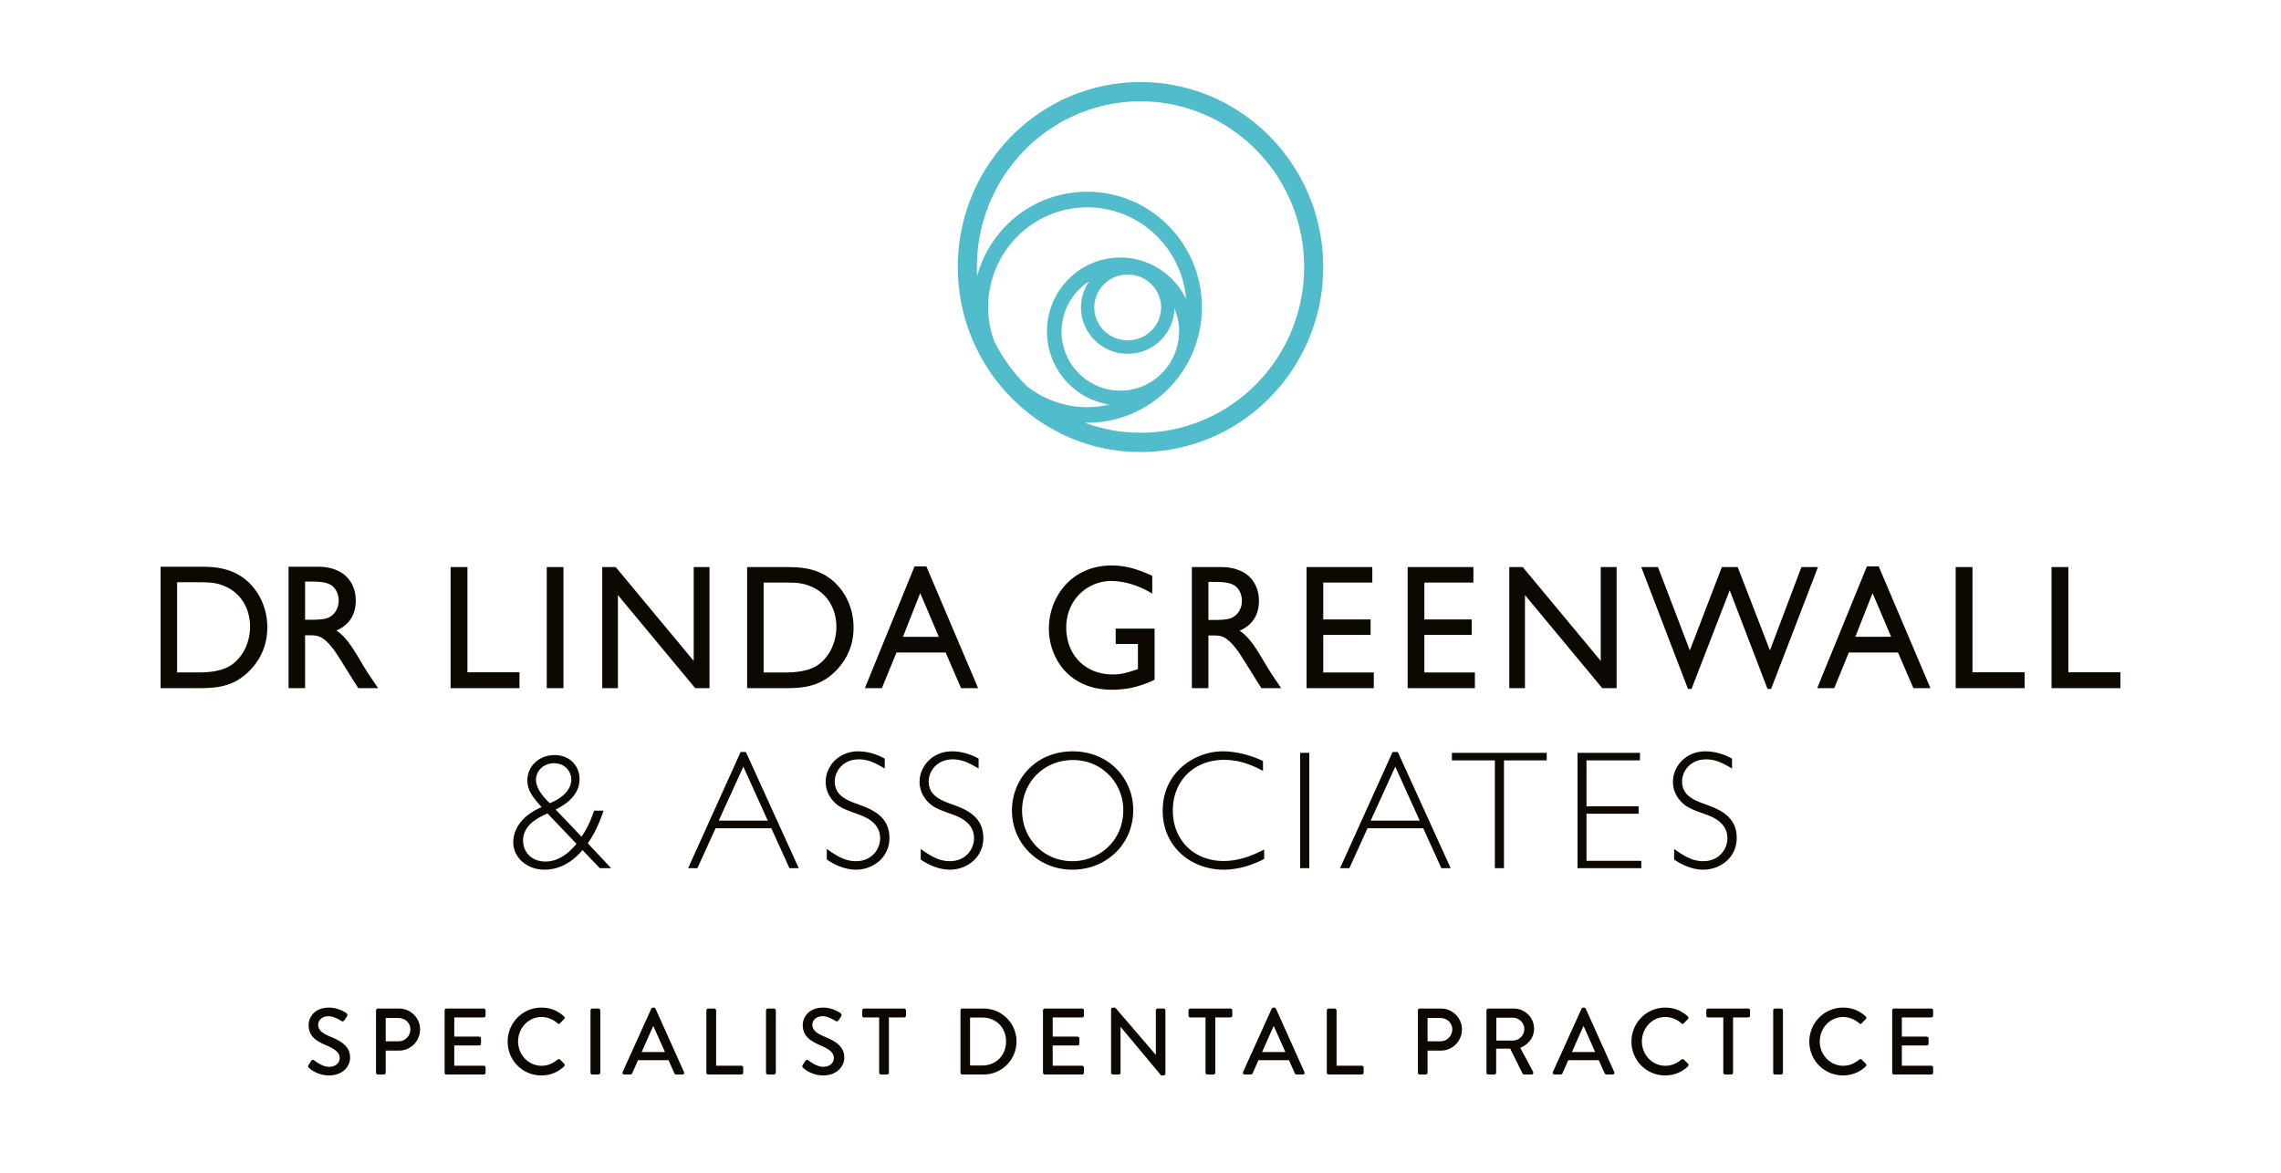
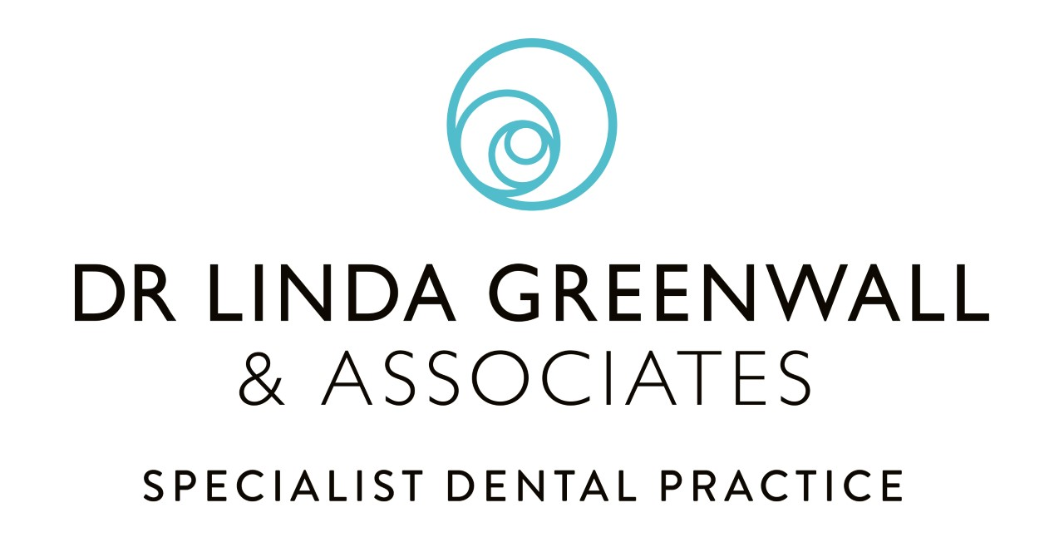
CHILDREN UP TO 3 YEARS OLD
- It is important to start good oral care even before the first tooth erupts into your babies mouth.
- Try and get your baby comfortable with you looking in their mouths.
- As soon as teeth erupt in your baby’s mouth brush them twice daily with a toothbrush appropriated to the child age.
- Brush last thing at night and one other time in the day.
- All children must be helped and supervised by an adult until at least 7 years old – children younger than this do not have the dexterity skills to brush their teeth effectively.
- Use toothpaste containing no less than 1000ppm of fluoride.
- Use a smear of toothpaste (a thin film of paste covering less than three quarters of the brush. Fluoride helps to prevent tooth decay.
- It is recommended to “spit don’t rinse” – spit the toothpaste out after brushing but to not rinse away with water. Encourage this where possible to get the most benefits of the toothpaste.
- Children must not eat or lick toothpaste from the tube.
- If for any reason your child cannot use a fluoride-based toothpaste, there is a fluoride free product that can be used as an alternative – GC Tooth Mousse contains minerals that also helps to prevent tooth decay.
- Do not give babies and children sugary drinks from a baby bottle as this can lead to baby bottle tooth decay – this is highly destructive for your babies’ teeth.
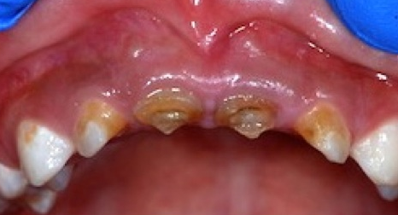
- This picture shows the damaging effects of baby bottle tooth decay.
- Only milk and water should be given in a baby bottle.
- Do not put your baby to bed with a bottle.
- At 6 months old an infant should be introduced to drinking from a free-flow cup.
- At 1-year old feeding from a bottle is discourage.
- Try to break habits such as thumb sucking and dummies by the age of 4 as this can detrimental affect the position of the teeth.

