DENTURE CARE

- You may struggle with wearing your denture at first – it can become sore and feel very different to normal. Make sure you persevere, and it will become much easier to wear. It is like having a new pair of shoes.
- Keeping your mouth clean is just as important when you wear a denture.
- Brush your remaining teeth twice a day with a fluoride toothpaste to prevent tooth decay and gum disease.
- Remove your dentures when sleeping to give your mouth a rest – this will help to reduce the risk of infections.
- Clean your dentures daily with a toothbrush or denture brush to remove any debris and bacteria, this will reduce problems like bad breath, gum disease, tooth decay and oral thrush.
- Soak your denture in a suitable cleanser and water – follow the manufacturers guidelines as to frequency and length of soak.
- Rinse your denture before placing it in your mouth again.

Denture stomatitis (Oral thrush) -
- This is caused by a fungus called Candida.
- People likely to be affected by denture stomatitis:
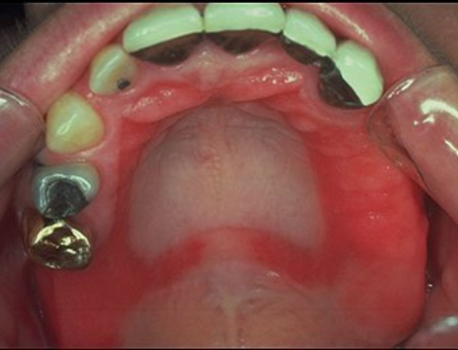
- Denture wearers.
- People who have difficulties keeping their mouth clean.
- Diabetic patients
- Anyone taking steroids, either through inhalers or by mouth.
- Anyone taking antibiotics.
- If left untreated this condition can cause soreness in the mouth and lead to poorly fitting dentures in the future.
- Always see your dentist if you are worried you may have denture stomatitis.

